Please CAREFULLY read the questions and follow instructions to answer.

Problem 0. Briefly and clearly report what you have done for Homework Assignment #4.

Problem 1. Build 'demo_fork.c' and run it, then try to change the red eyes to 'browse.tcl' and run it again.

通过C代码启动tcl?

错误1 Gcc demo_fork.c

不能执行 a.out

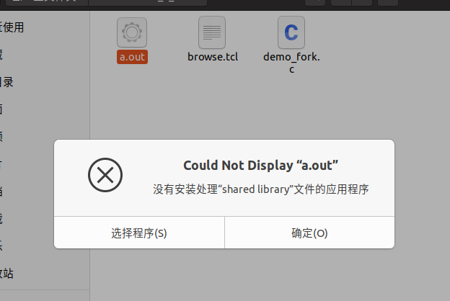

解决方法:

终端中打开,成功

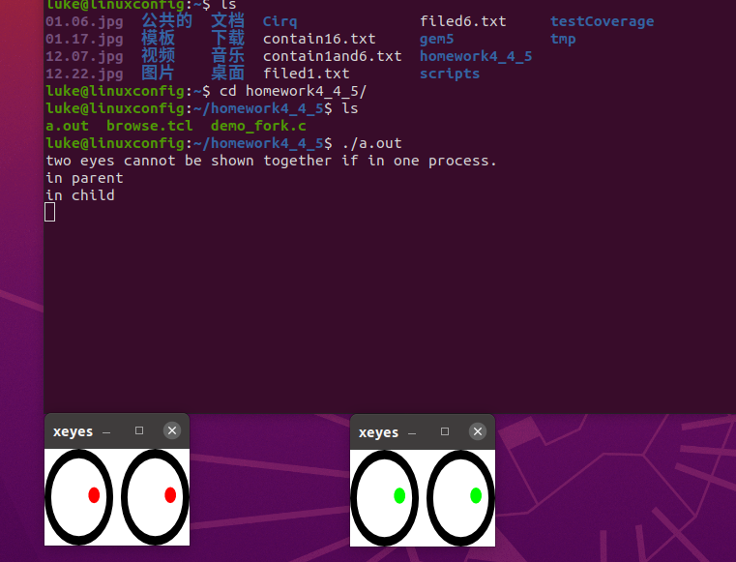

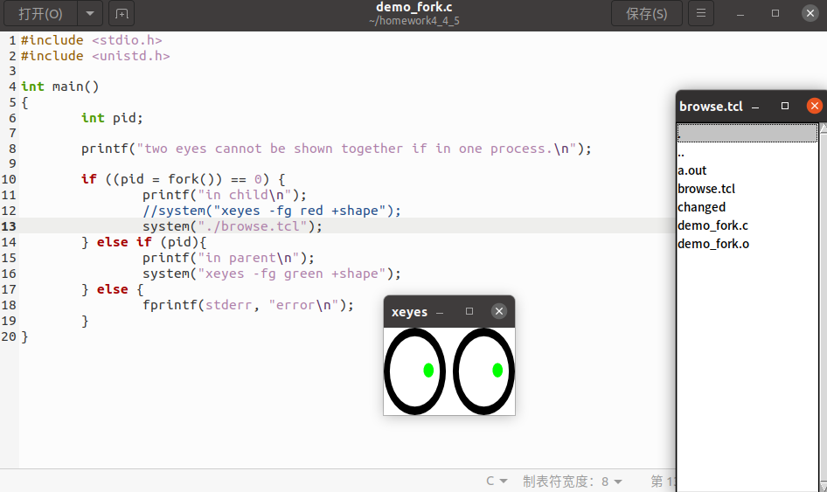

成功把红眼睛改为browse.tcl'

错误2 : bash: ./browse.tcl：/usr/bin/wish：解释器错误: 没有那个文件或目录

解决方法: apt-get install -y wish ,就可以了.

Invoke more directory browsers from browse.tcl. Use 'pstree' to see the process hierarchy for all of them,

再点击一个目录就可以了and show the hierarchy with a screenshot.如下图

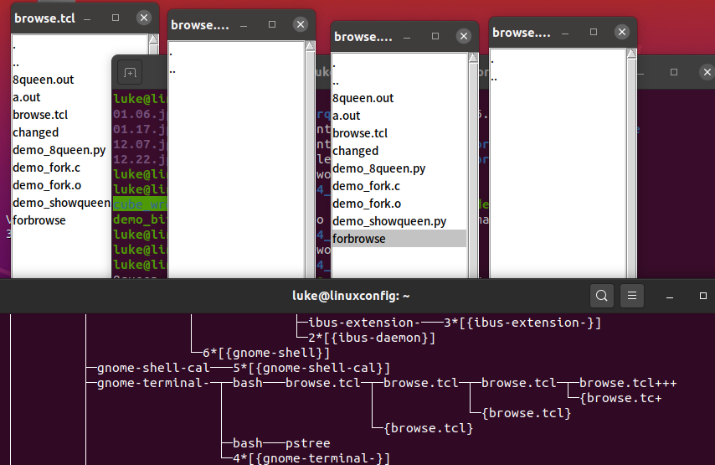

Problem 2. Run Python scripts of demo_8queen.py and demo_showqueens.py,

read the source code, comments and their outputs.

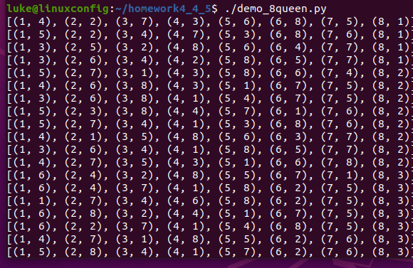

输出到8queen.out即可

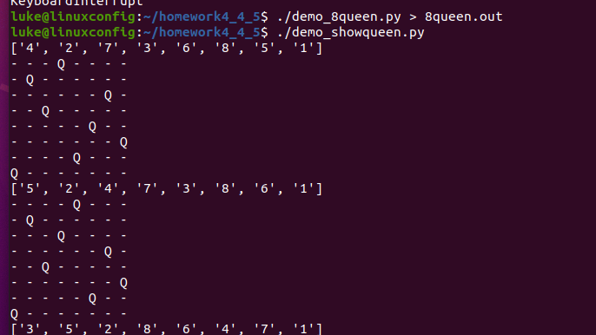

Then (OPTIONALLY) write a Perl or Python script to analyze the solutions in 8queen.out,

and show how many kinds of the solutions are unique.

方法: 把第一个存入, 第二个检查是否为镜像, 第一个点左右对称? 上下对称?相加为8?

旋转怎么检查?

(symmetrical solutions are not considered as unique, for example, one solution being mirrored or rotated should be eliminated from the unique list)